**Supplemental Figures**

**Figs. S1-S9**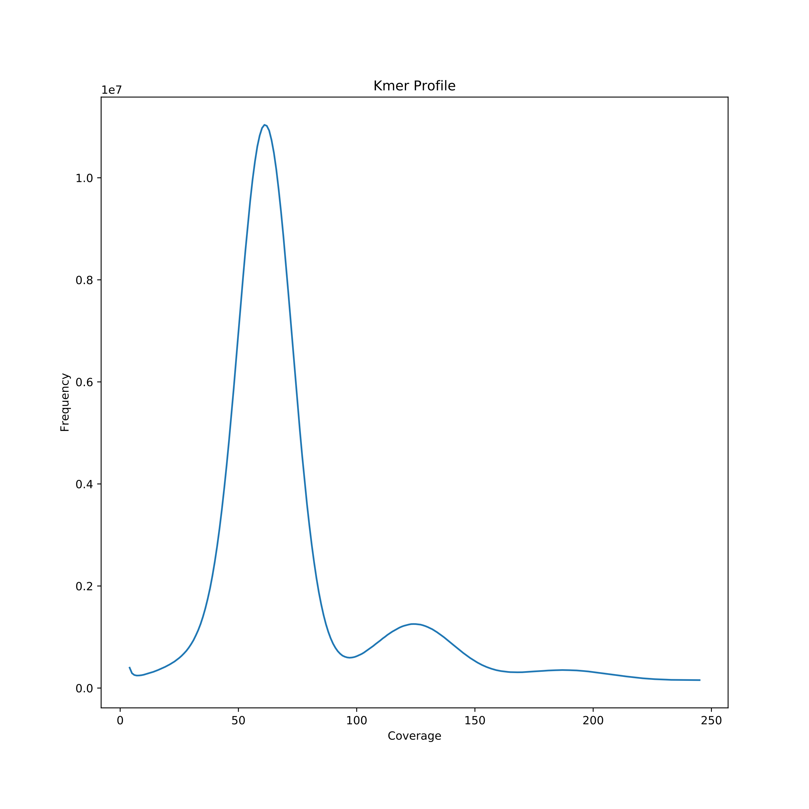

|  |  |  |  |
| --- | --- | --- | --- |
| Model | Genome size | Heterozygous rate | Repeat structure rate |
| H0 | 1092320000 | - | 71.43% |
| H1 | 1092510000 | 0.19% | 69.83% |

**Fig. S1 *k*-mer (*k*=17) distribution and genome size estimation by H0/H1 model using GCE for *Gastrodia elata* genome.**

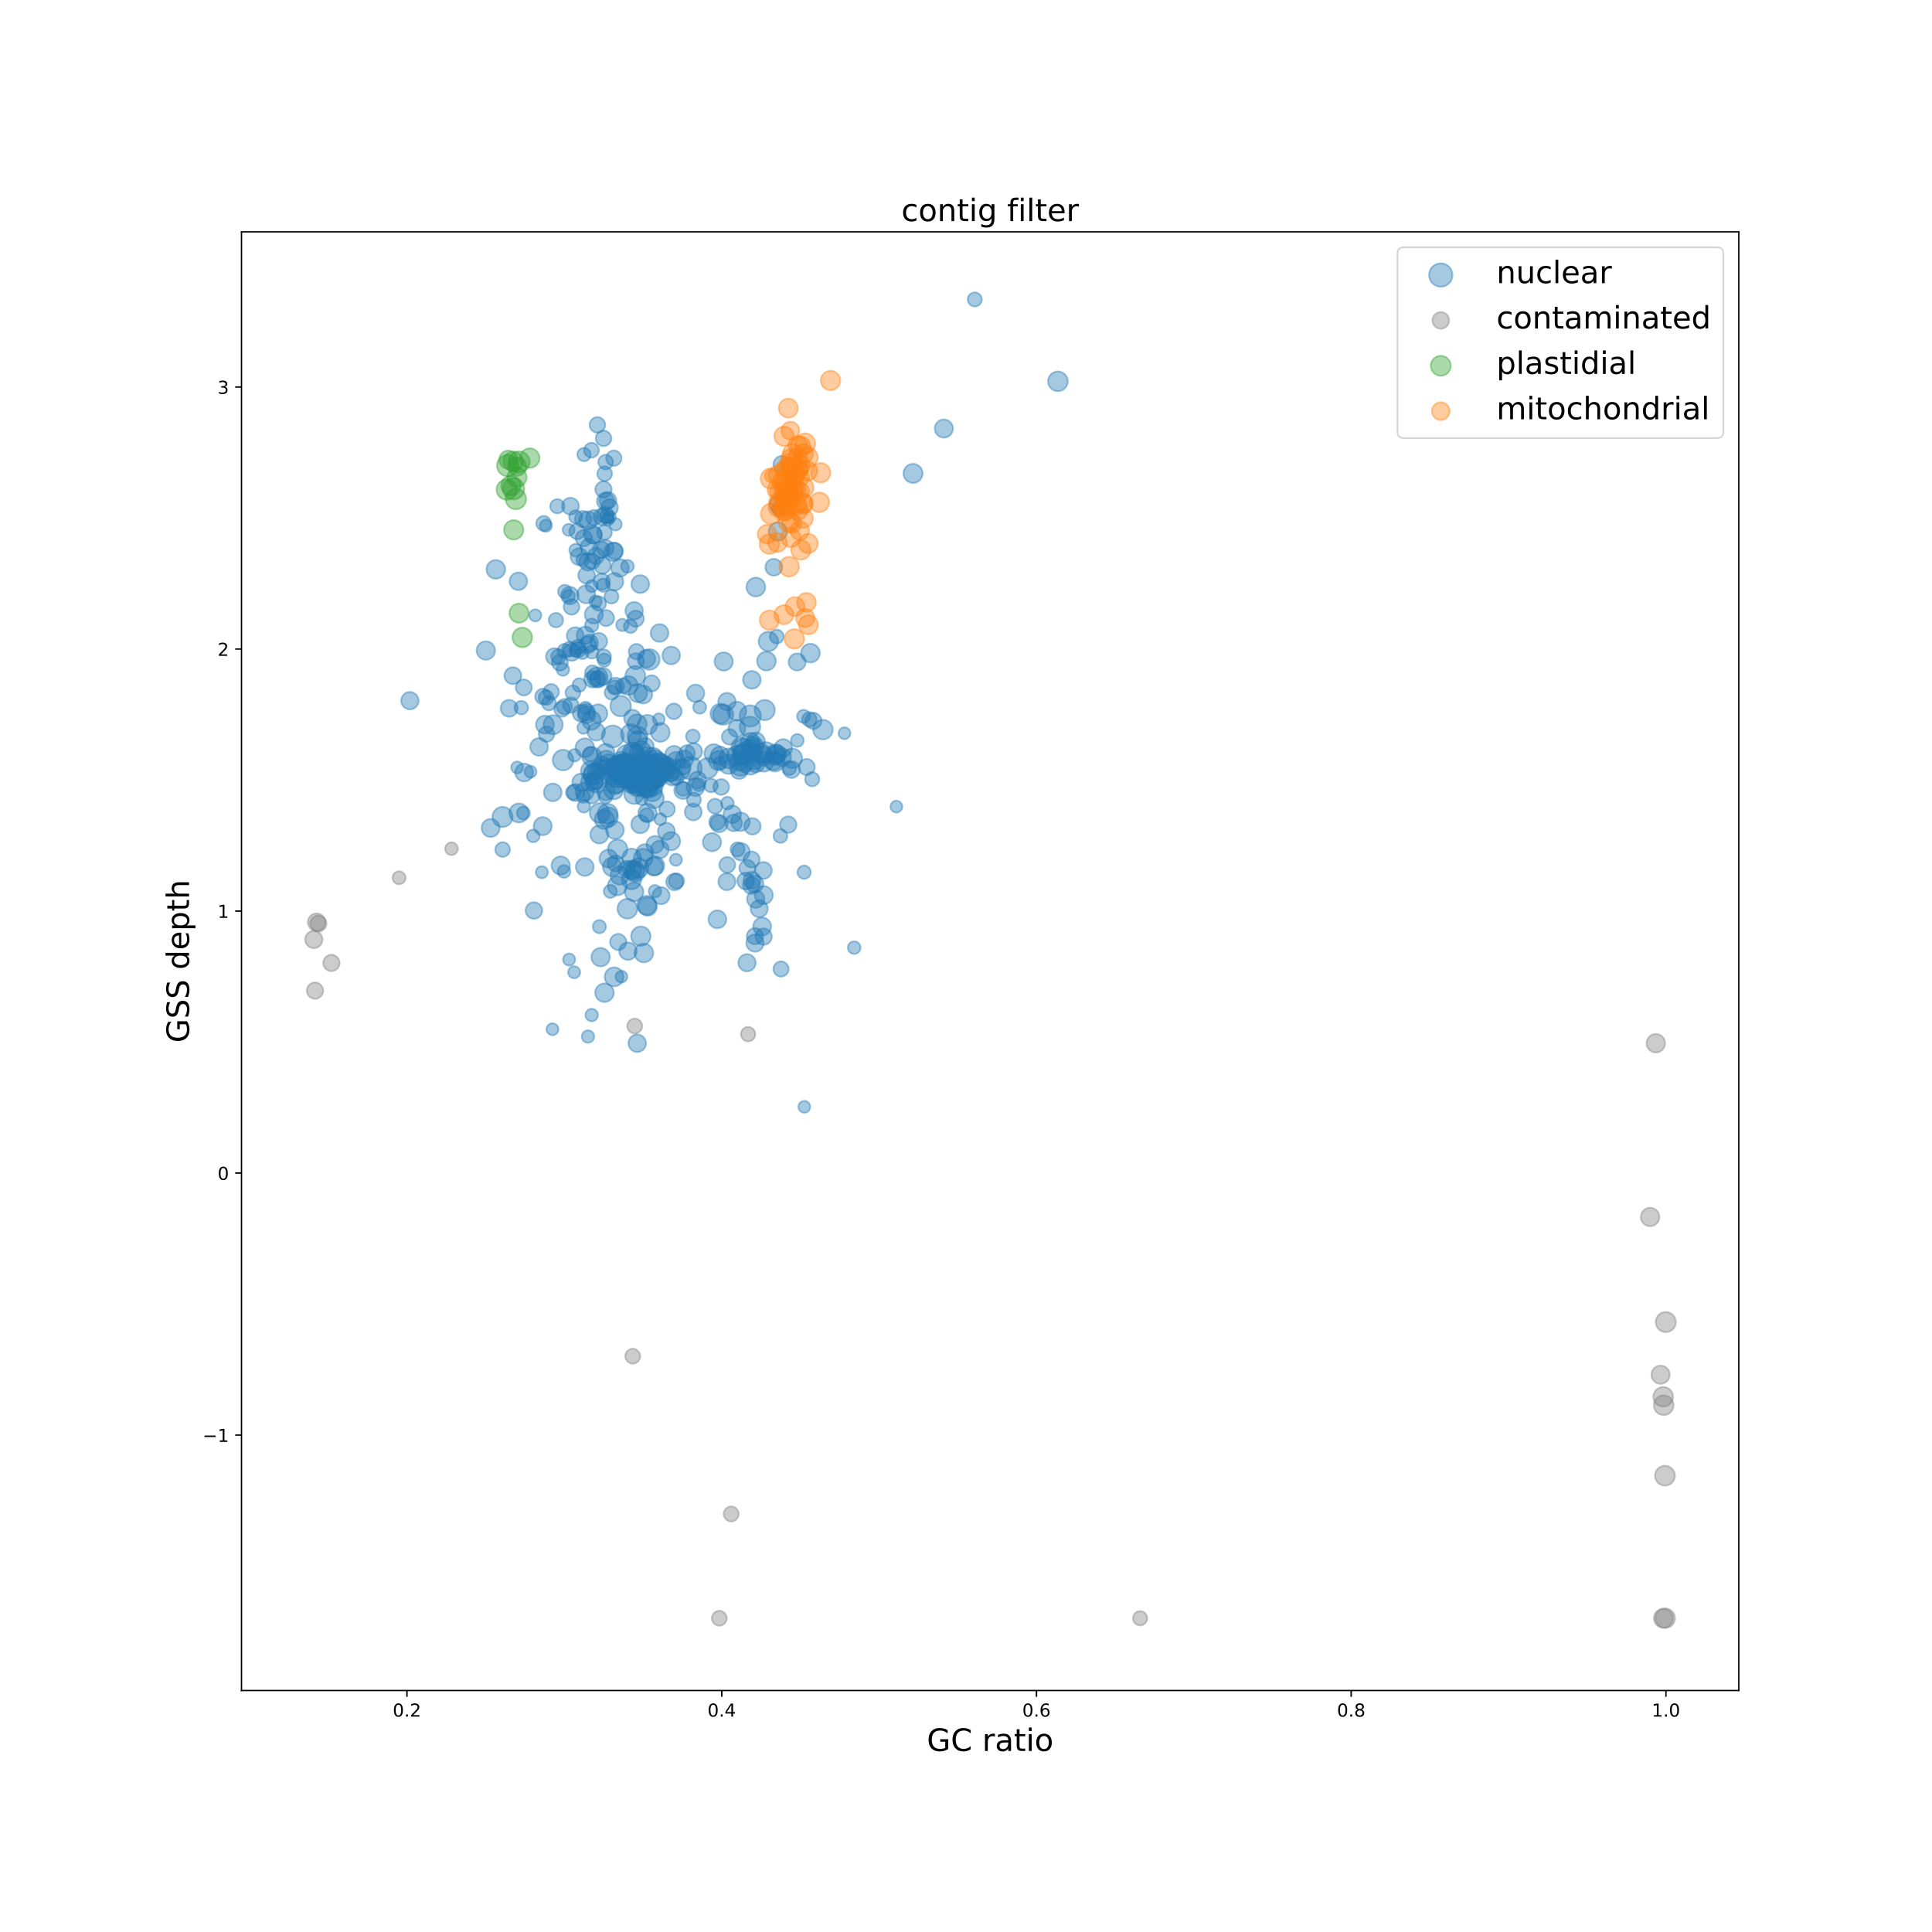

**Fig. S2 Identification of contamination and organelle sequences using GC ratio, genome survey sequence data mapping depth, and result of organelle genome BLAST.**

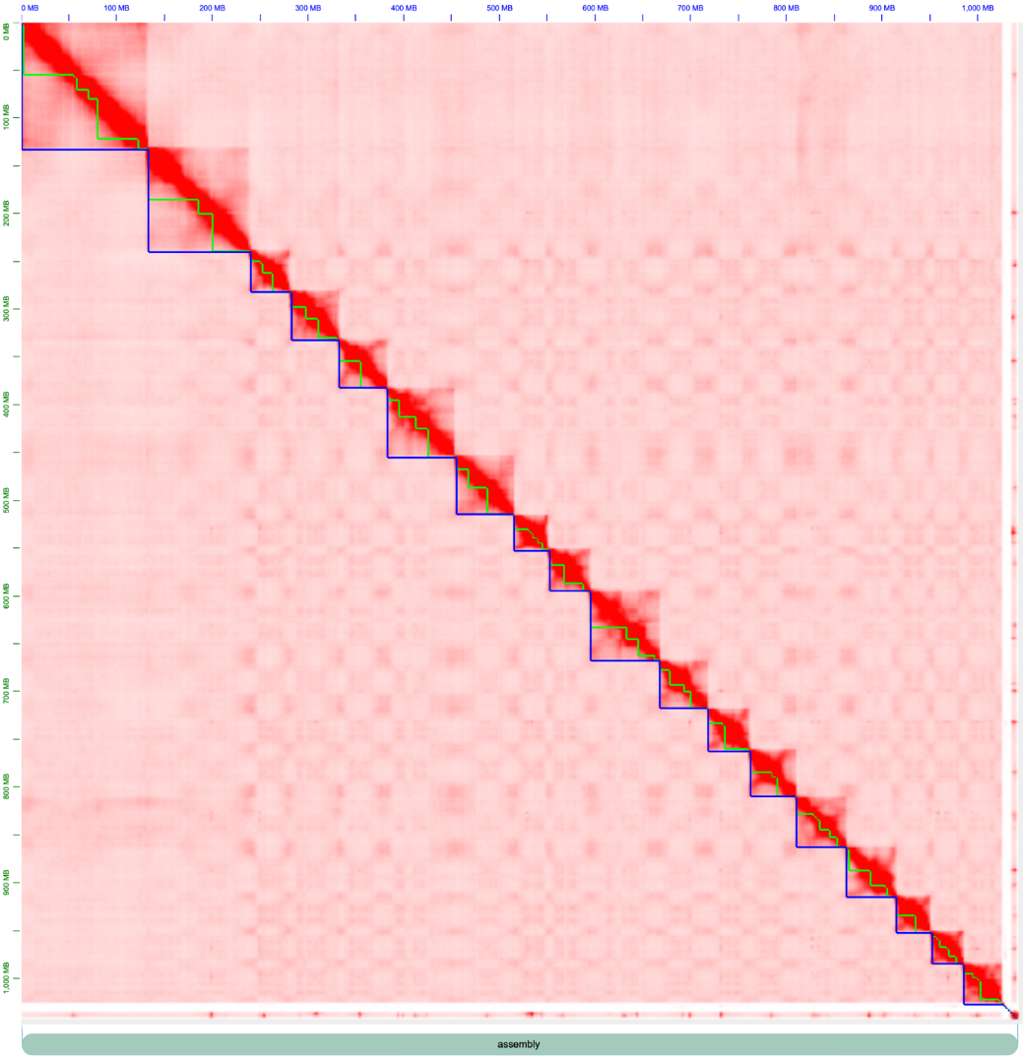

**Fig. S3 Hi-C contact map of the *Gastrodia elata*.**

The blue edges of each square indicate the range of the chromosome. The serrated green lines represent the contig fragments.

361

6171

18608

Identical coding genes: 16004

Identical pseudogenes: 423

Structurally improved coding genes: 2170

Structurally improved pseudogenes: 11

Coding genes: 2941

Pseudogenes: 3230

18969 genes annotated by Yuan et al. (2018)

21115 genes and 3664 pseudogenes annotated by this work

**Fig. S4 Comparison of gene annotation from this study with that from Yuan et al. (2018).**

**Fig. S5 Venn diagrams of lost genes in three mycoheterotrophic plants and three parasitic plants.**

Mycoheterotrophic plants: *Apostasia shenzhenica* (Ash), *Vanilla planifolia* (Vpl), and *Gastrodia elata* (Gel); parasitic plants: *Striga asiatica* (Sas), *Cuscuta australis* (Cau), and *Sapria himalayana* (Shi).



**Fig. S6 The maximum efficiency of PSII photo-chemistry (Fv/Fm) in *Gastrodia elata*, *Dendrobium officinale*, and Arabidopsis.**

*Gastrodia elata*, *Dendrobium officinale*, and Arabidopsis were photographed under the brightfield(**a**) and fluorescence (**b**) mode on a pulse-modulated fluorimeter Imaging-PAM (Walz, Effeltrich, Germany).



**Fig. S7 Levels of salicylic acid in *Gastrodia elata*, *Phalaenopsis equestris*, and *Dendrobium catenatum* after being challenged by a bacterial pathogen.**

SA levels were measured 24 h after *Pseudomonas syringae* pv. *tomato* DC3000 infection in *G. elata* (tuber), *P. equestris* (stem), and *D. catenatum* (stem). Asterisks indicate statistically significant differences of SA contents (*t*-test; ** P < 0.01; *** P < 0.001). n.s. = not significant.



**Fig. S8 Gene loss in the** **thiamine (vitamin B1) and phylloquinone (vitamin K1) biosynthesis pathway**.

**(a and b)** Simplified biosynthesis pathways of thiamine **(a)** and phylloquinone **(b)** in *Gastrodia elata* and *Cuscuta australis*. **(c and d)** The contents of vitamin B1 **(c)** and K1 **(d)** in *G. elata* (tuber), *Armillaria* (rhizomorph), *Dendrobium officinale* (stem), *Solanum tuberosum* (tuber), and *C. australis* (seedling).



**Fig. S9 Gene loss in the MEP and mevalonic pathway**.

**(a)** Simplified MEP and mevalonic pathway in *Gastrodia elata* and *Cuscuta australis*. **(b-d)** The contents of lutein and zeaxanthine **(b)**, β-carotene **(c)**, and abscisic acid **(d)** in *Arabidopsis thaliana* (leaf), *Dendrobium catenatum* (stem), *C. australis* (seedling), *Armillaria* (rhizomorph), and *G. elata* (tuber).

**Reference**

**Yuan, Y., Jin, X., Liu, J., Zhao, X., Zhou, J., Wang, X., et al.** (2018) The *Gastrodia elata* genome provides insights into plant adaptation to heterotrophy. *Nature Communications*, **9**, 1615. <https://doi.org/10.1038/s41467-018-03423-5>